CO 3302 Computer Engineering Project

DR DELIVERY

W.M.K.N.B WEERASINGHE

# Abstract— Developing a real time web app called “dr delivery”. Almost every person living in today's society leads a very busy life. Due to this busy lifestyle and current covid-19 situation in the world people tend to buy online and get delivered instead of going to the shop. Although everyone thought coivd-19 will come and go ,it has come to stay. this app provides solution to these problems. As the name suggests “Dr.Delivery” is an online e commerce and delivery platform where sellers can sell any kind of grocery and food products and buyers can buy any type of products according to their likes and dislikes. And also there are delivery persons to deliver the goods. Sellers can get registered, upload photos of products , add titles, descriptions and their region. Buyers can select by region, price range , name. And they can view the product, add the items to cart, rate , select pay online or pay by cash. When there is a delivery opportunity delivery guys are notified. And then a delivery guy can take the order and deliver. Real time location of the delivery person is displayed to the customer.

**Index Terms**— REAL TIME – The actual time during which a process or event occurs, JS - Java Script, App – Application, API – Application program interface, SPA - Single Page Application ,MVC -Model,View,Controller , ACL -Access Contol List

————————————————

1. W.M.K.N.B Weerasinghe with the Department of Computer Engineering, Faculty of Engineering, University of Sri Jayewardenepura, EN86232. E-mail : [en86232@sjp.ac.lk](mailto:en86135@sjp.ac.lk)

—————————— ◆ ——————————

# 1 Background

Nowadays people have a very busy life style and prefer to purchase online than never before. This will provide a platform for people to do their grocery purchases online while still having the freedom to choose where their grocery and food products are bought from. Although there are some companies in Sri Lanka that have entered in to this business they are not much customer friendly. Those companies have their own stores and prices are very high. Here customer has the freedom to select the store or shop according to desired price range. Here goal is making grocery purchasing easier and convenient through a web platform.

In Sri Lanka (in 2019 January) total population was 20.98 million. Total mobile subscription was 28.71 million.Total internet users were 7.13 million. Annual population growth compared to the previous year is 71 thousand people. And growth of annual mobile subscriptions and internet users compared to previous year 2018 are 448 thousand and 413 thousand according to Hoot suite [1]. As we can see it, e commerce market is growing in a higher percentage every year. As there are very few companies in this business this is still a good market. And the other thing is they only operate in Colombo. We can take it outside to Colombo. And also if we can apply this same concept island widely it will be a new revolution in e commerce industry. How markets work in Colombo and Outside Colombo are totally different.

During Covid 19 epidemic situation almost anyone does not want to travel more and get contacted with the virus. And what most of the people do is ,calling a nearby store or shop and order their goods list and someone delivers the relevant goods to their houses. In village areas shops are not operated like in Colombo , normally customer knows the seller and seller knows customer. This app provides a platform to do that online real time more conveniently improving the bond between seller and buyer.

And the other big thing is we can reduce is the middle man cheating on both customer and seller. For example normally a coconut in Puttlam district is around 40 Rs and in Colombo same coconut is around 100 Rs. This is same with the other products like rice , vegetables and fruits. What if we can have a good delivery system when customer order directly from the seller and there are delivery trucks which go between districts and collect from the seller and get delivered to the customer.This needs more infrastructure handling skills than making a web platform. This is like applying the Ali Baba model in Sri Lanka. We can pay a better price for seller(farmer) and sell the product for a lower price than in the market. This is the biggest scope that can be applied in Sri Lanka.

# 2 Objectives

The aim of this project is to provide a user-friendly and easy method to do their shopping. And provide a platform to customers to save time that they spend on stores and giving the customers to select a store and order the item they want while they can watch the details of the product.s And providing a platform to customers where they can order from any store according to price range, region and name. And customers are able to add products to carts, and remove mistakenly added items from the cart. And to customers can use preferred method of paying, they can pay online or pay by cash. And review both delivery guy and the product. All three customer, seller, delivery person can get registered inputting their basic details .And this provides a platform to sellers to get registered their shop easily, add any product, add product image, add title of the product, add price, add a description, add region , notify customer when the item is handed over to delivery person, notify delivery persons when there is a delivery opportunity.And the app provides a platform to delivery persons to take the order, deliver the item. Admin can retrieve all the order statics and analyze them. The system will provide user authentication, access privileges and also user can report system issues,clear verification requirements,user session will be clearly monitored,Hashed passwords.

# 3 Methods

One of the main features of this software is that it has used Redux to manage all the states of the app using model, view , controller approach. Redux is all about state. It is based on 3 principles. The state of the app is stored in one JS object. The state is read only , but we can change the state by describing a change with another JS object called action. Changes are executed by [pure functions](https://reactjs.academy/blog/introduction-to-redux-explained-with-simple-examples/" \l "pure-functions) called [reducers](https://reactjs.academy/blog/introduction-to-redux-explained-with-simple-examples/" \l "redux-reducer). A reducer accepts the current state and an action and returns a new state or the same state [2] Redux follows the [one way data flow of React](https://reactjs.academy/blog/introduction-to-thinking-in-react/" \l "components).JS. Redux keep the state of the application in a single read only JS object. to change the state we dispatch actions and [reducers](https://reactjs.academy/blog/introduction-to-redux-explained-with-simple-examples/" \l "redux-reducer) process the changes. All the reducers receive all the actions. Because of using Redux, managing states of all 3 types of users is optimized.

Another major feature of this application is it is built using asynchronous programming . As this is a real time web application all the data should be handled real time without any errors. Asynchronous programming improves the performance and responsiveness of the application. Asynchronous programming makes it possible to express waiting for long running actions without freezing the program during these actions [3].

**Step 01 Requirement specification**: Identifying the requirements and creating the priority list to focus on each segment and functionality of the project.

**Step 02 Creating wireframes and prototype**: Using the wireframes brings more clarity to the project and it helps to visualize the views and identify the goals achieved by each segment. Using prototypes give the overview of the finalized product.

**Step 03 Designing the architecture**: Creating a logical layout of the website according to the requirements gathered.

**Step 04 Deciding the development method**: In this project, the website is developed using all the logical fuctionalities performed in the frontend, using a frontend with backend as a service using firebase. And the web site is built as a single page application. A single-page application (SPA) is a web application that interacts with the user by dynamically rewriting the current web page with new data from the web server, instead of the default method of the browser loading entire new pages. Using SPA improves responsiveness of the website becuase single-page applications don't update the entire page but only required content, they significantly improve a website's speed.

**Step 05 Selection of framworks to implement the frontend and the backend**: For the frontend implementation React JS library was selected because it supports to develop dynamic single page applications with MVC approach with Redux, restul API handling, dependency injection and etc.

**Step 06 Selection of the database model**: Relational, non relational, Object oriented was heavily used database models and Non relational noSQL approach was more appropriate for the application because of it can handle large volumes of data at high speed and it is more developer friendly option. So in the product real time cloud firestore was used.

**Step 07 Implementation the features**: Implementing each feature such as Signup/Login for all 3 types of users, defining ACL according to user type and implementing each user type’s special features, Online Payments with stripe JS, Using redux to manage state of the whole apllication, using asynchronous programming. HTML, CSS, Bootrap 4, React Bootstrap, React Strap was used for styling. Website consists 96 % Javascript, another 3 % CSS, and 1 % HTML.

**Step 08 Testing and debugging**: Unit testing, integration testing, System testing was performed at each stage.

# 4 Challenges

Choosing the appropriate language and framework for the development process. This was a big challenge. I had to change the backend and database 3 times during the development. 1st I started using MongoDB but as it doesnot support realtime data updation had to move to Firebase cloud firestore.

Cross Origin Errors: A security mechanism that browsers implement called the same-origin policy. The same-origin policy fights one of the most common cyber attacks out there: cross-site request forgery. In this maneuver, a malicious website attempts to take advantage of the browser's cookie storage system. Using access control allow origin method this error can be rectified. Adding appropriate headers from the servers is another method of solving this issue.

Frequent updates in Firebase and React Js was a big challenge. This was a problem which couldn’t be solved using any methods other than the re-writing the whole program and installing new version. In the beginning of the project the stable version of React was 16.8 and now it is React 17.0 also some services used in the firebase is not compatible with older vesions of the React.

Other biggest challenge was computational resources were not enough. It lead to so many crashes during the development process. Had to restart the computer when pc got stuck.

# 5 Graphical user interfaces

Figure 01 : Home page with login types and carousel

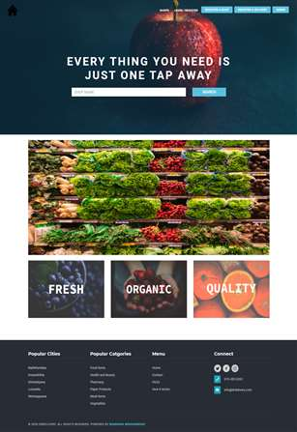

Figure 02 : Whole page is mobile responsive

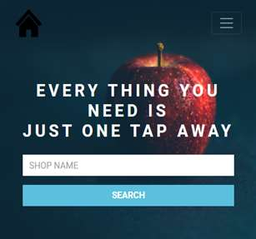

Figure 03 : Create Account (3 types)

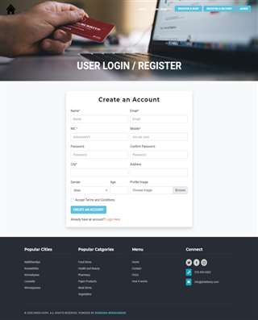

Figure 04 : User Login (3 types)

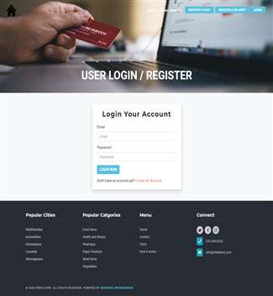

Figure 05 : Can view shops and items, but can’t order without logging

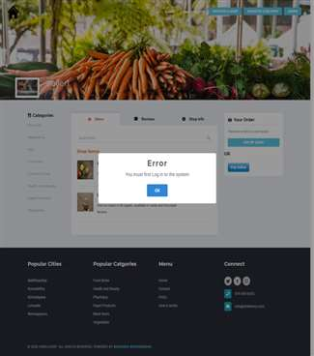

Figure 06 : Can login and order, Navbar changes according to user type

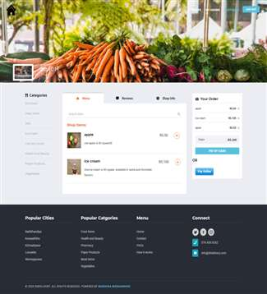

Figure 07 : Pay Online with stripe

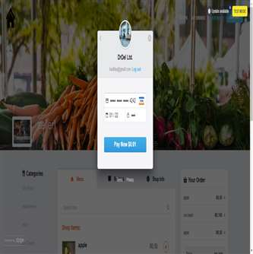

Figure 08 : User can view the state of the order real time

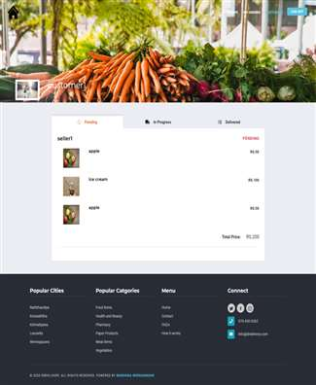

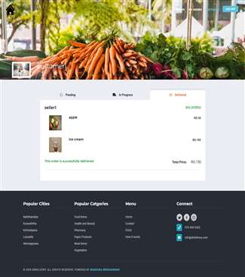

Figure 08,09 : State of order is displayed real time to users

Figure 10 : Seller can add orders, add description, type and etc

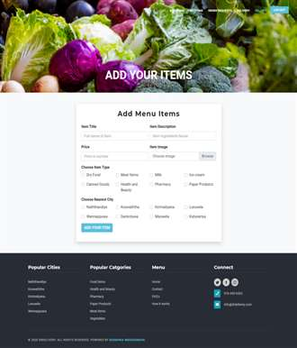

Figure 11 : Seller can view his itmes

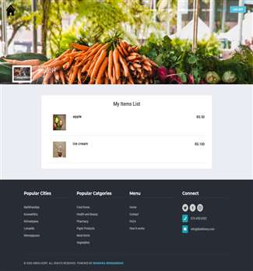

Figure 12 : Seller get notified about orders

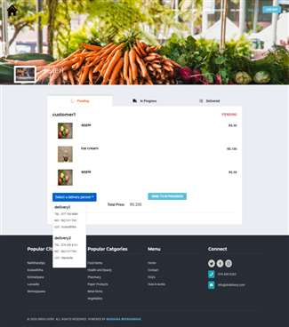

Figure 13 : Seller can select delivery persons according to their location.

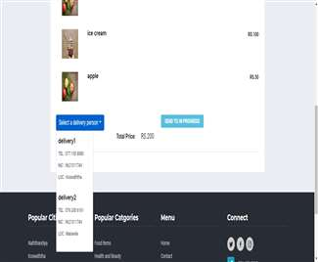

Figure 14 : State of order is displayed real time to seller

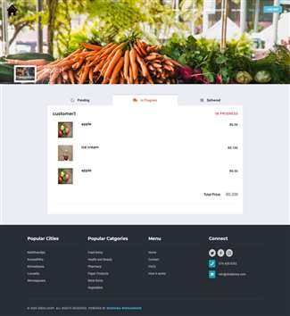

Figure 15 : State of order is displayed real time to delivery person with seller, customer data

Figure 8 : Doctor’s category selection

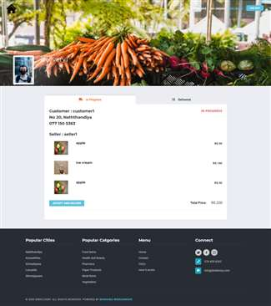

Figure 16 : Users can view reviews and shop info when ordering items

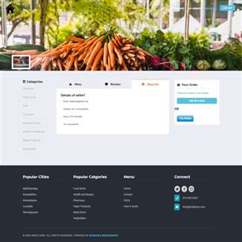

# 6 Future Development

* Developing the website to support multiple languages.
* Get direction and routes to the seller’s location, delivery person and customer through optimization.
* Allow users to chat with the sellers and delivery persons real time. Hope to add a chat system to talk with each other.
* Allow users to order items and go and get them selves.

# Conclusion

E-commerce is continuously progressing and is becoming more and more important to businesses as technology continue. Every day more people connect to the Internet and grow increasingly comfortable with digital transactions. Finally the current pandemic situation in the world displays what are the advantages of having E-commerce platforms.

**Acknowledgment**

The author wishes to thank Dr. Randima Dinalankara, Dr. Udaya Wijeynayaka, Dr. Krishanthmohan Rathnam, Dr. Bhagya Nathali Silva, Ms. Dilani Ranaweera, Mr. Ishara Dissanayake, Ms. Akarshani Amarasinghe for the immense support and guidance throughout the project.

**References**

[1] “Digital 2019 Sri Lanka ". https://www.slideshare.net/DataReportal/digital-2019-sri-lanka-january-2019-v01 (accessed Apr. 17, 2020).

[2] “What is Redux. Learing the basics” https://medium.com/leanjs/introduction-to-redux-redux-explained-with-very-simple-examples-b39d7967ceb8 (accessed May ,20 2020).

[3] “Introducing asynchronous Javascript” Available: https://developer.mozilla.org/en-US/docs/Learn/JavaScript/Asynchronous/Introducing( accessed Nov , 6 2020)

.